Static Website Deployment
By – Dilip kumawat
To deploy a static website, we use S3 and route53 services
step1: In S3, create a bucket named like your domain name -thesnm. shop and upload files
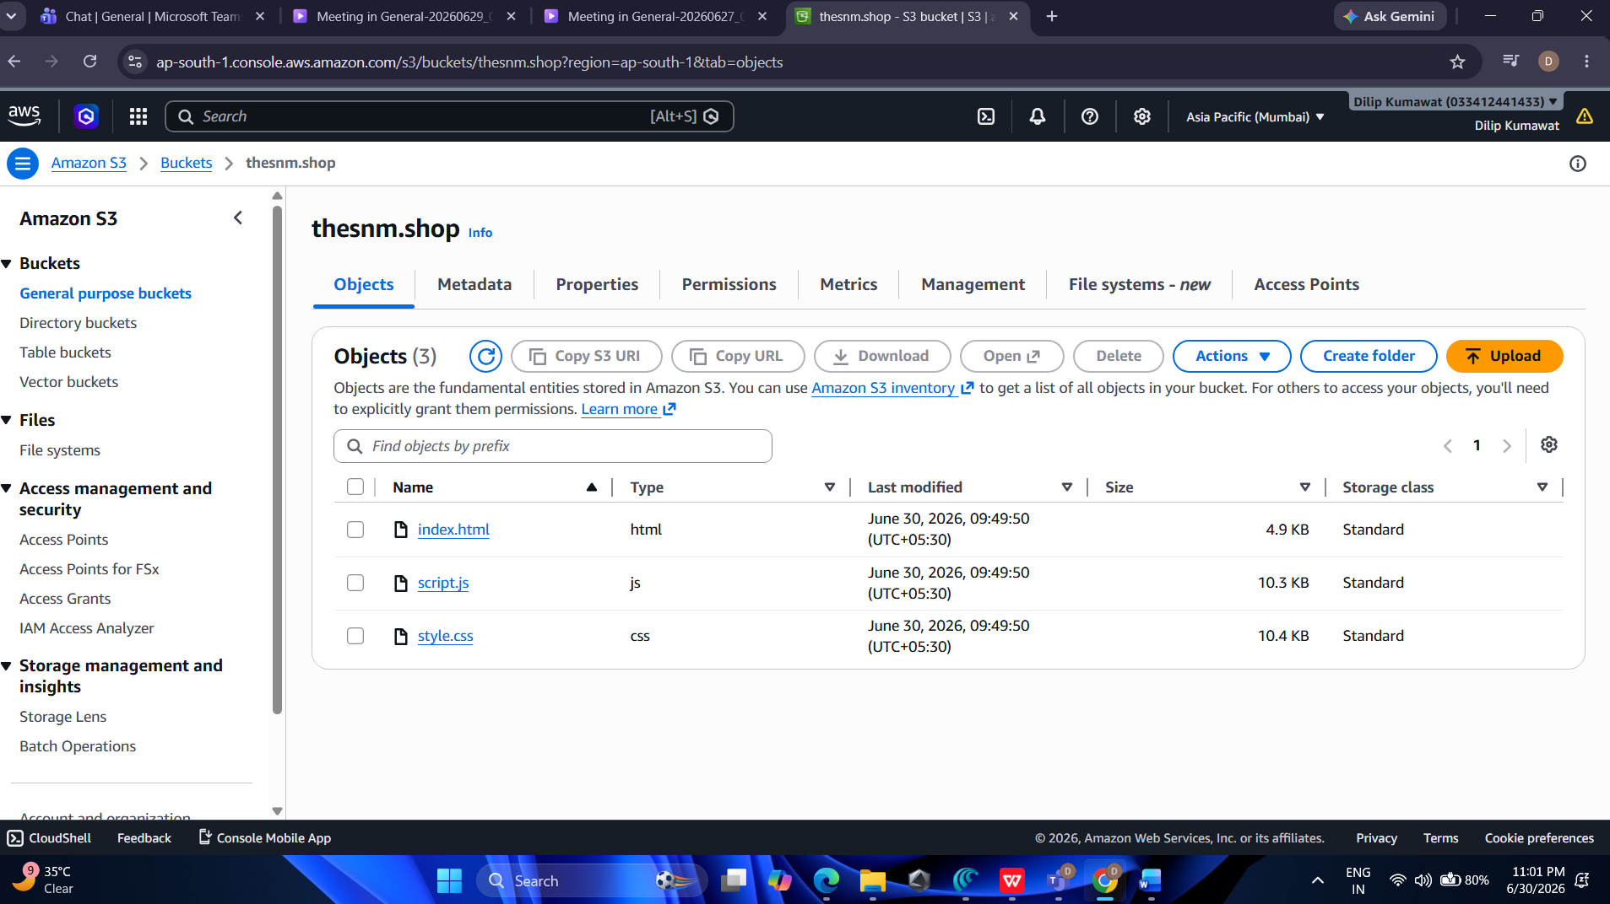
and make a public access and edit static website hosting
make sure you upload a index.html .

step2: Go to Route 53 and create a hosted zone for your domain name, then after the snm. shop, create all the NS servers are change them with your domain like
in Hostngir->Domain->NS->change server
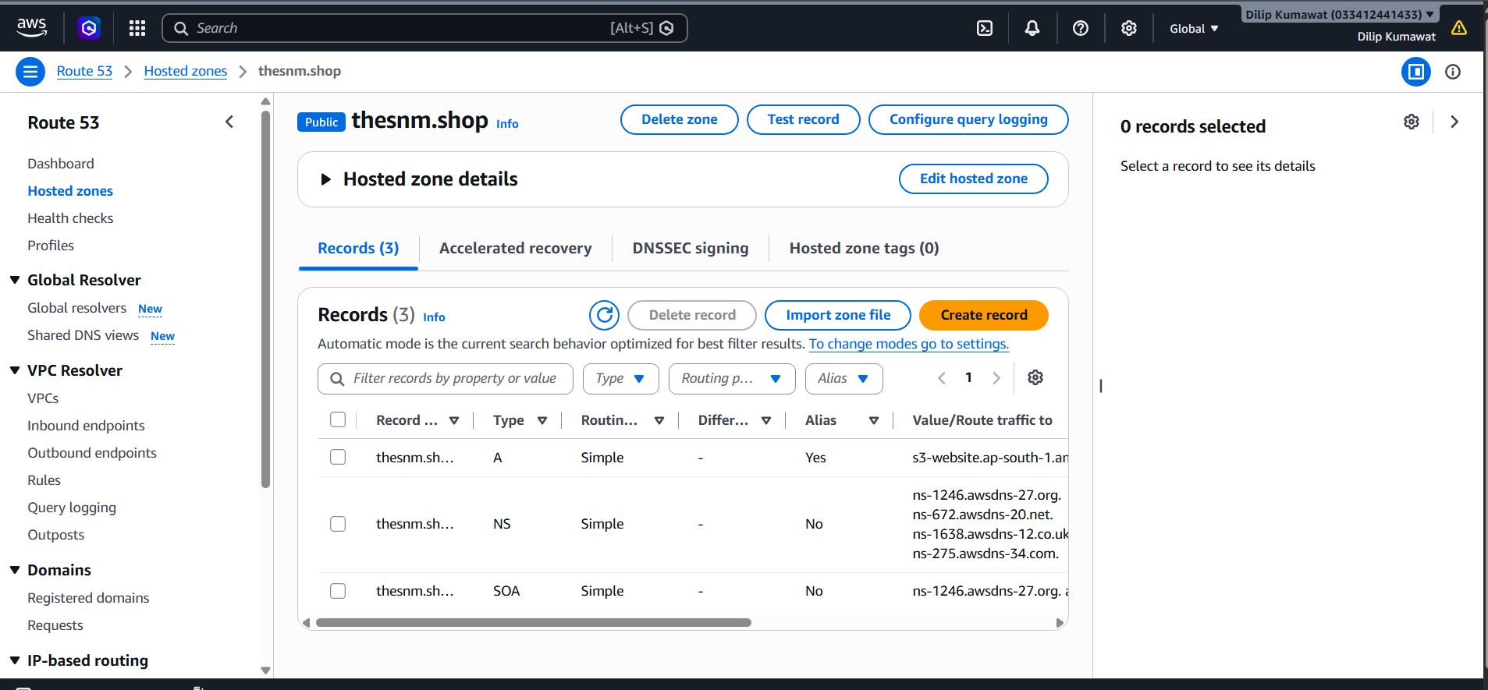
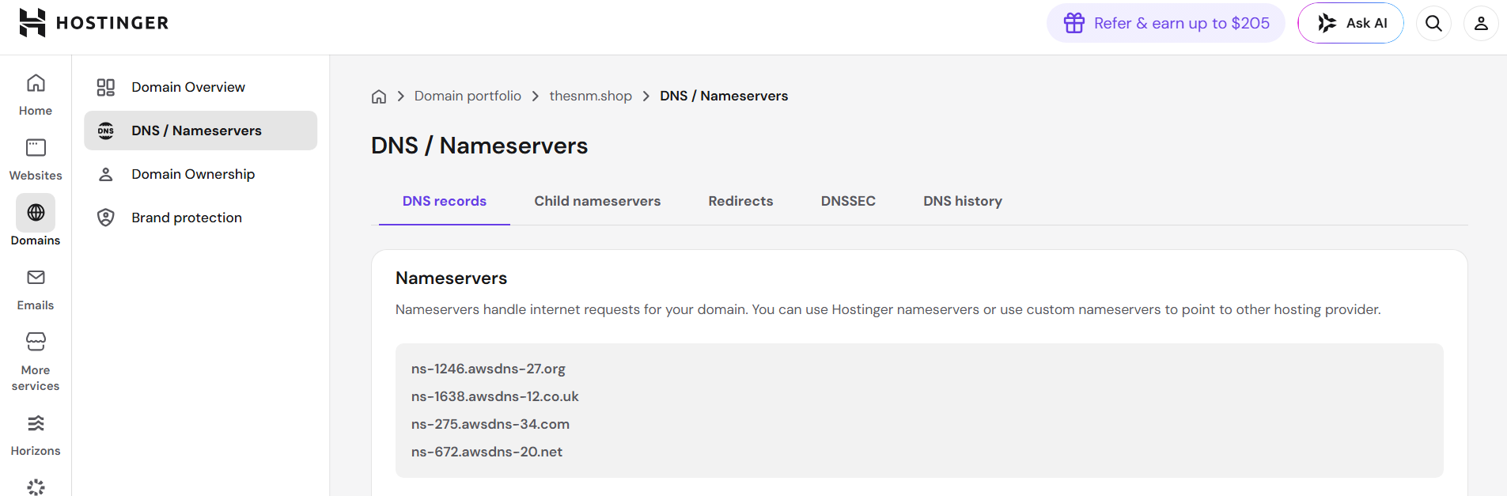
after some 12 to 24 hours it will be deployed
step3. In route53
->create record alias ->enable ->endpoint->alias to s3 endpoint ->
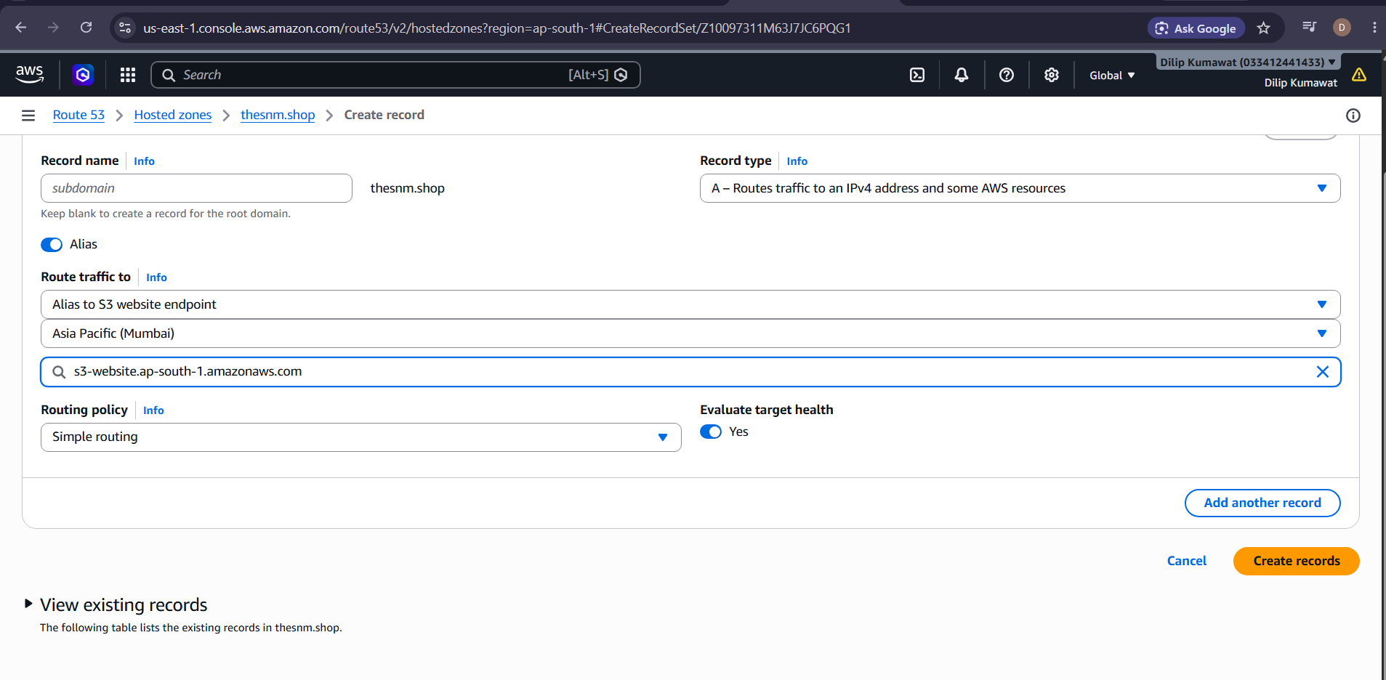
step 4:-
After some time thesnm.shop will be on the site
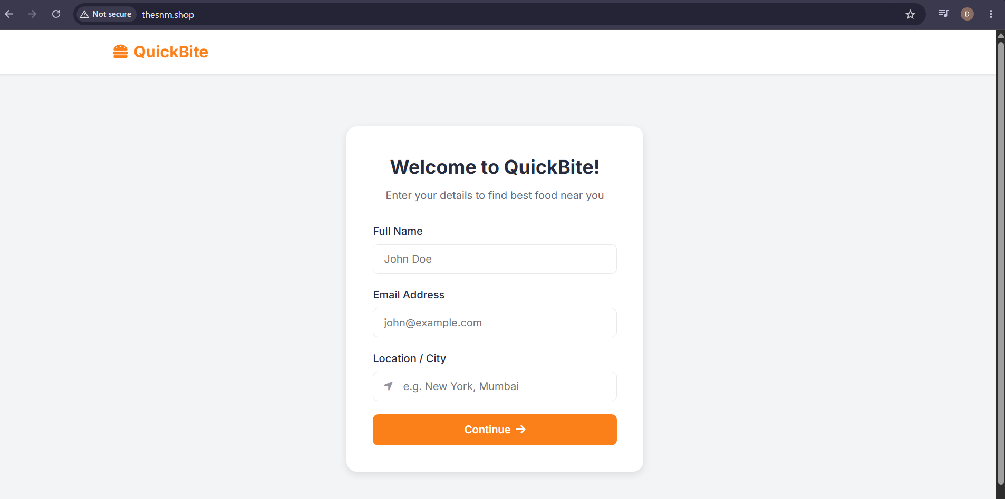
It was a static website deployment of a restaurant website
now it will will open by link--http://thesnm.shop/
http://thesnm.shop/
Thank you

